** NAME:Aryaman_Mishra**

**REG. NUMBER: 19BCE1027**

**EXPERIMENT NO.2**

**DATE: 28-1-22**

**PSYCHOLOGY LAB RECORD BOOK FORMAT**

* **TITLE OF THE EXPERIMENT**

Rosenberg's Self-Esteem Scale

* **AIM:**

To compare group and individual scores obtained from the Rosenberg Self-esteem Scale.

* **MATERIALS REQUIRED:**

Rosenberg Self Esteem Scale Website,Graphs,Google Form Data

* **DESCRIPTION OF TEST:**

The "big five" are broad categories of personality traits. While there is a significant body of literature supporting this five-factor model of personality, researchers don't always agree on the exact labels for each dimension.

You might find it helpful to use the acronym OCEAN (openness, conscientiousness, extraversion, agreeableness, and neuroticism) when trying to remember the big five traits. CANOE (for conscientiousness, agreeableness, neuroticism, openness, and extraversion) is another commonly used acronym.

It is important to note that each of the five personality factors represents a range between two extremes. For example, extraversion represents a continuum between extreme extraversion and extreme [introversion](https://www.verywellmind.com/signs-you-are-an-introvert-2795427). In the real world, most people lie somewhere in between the two polar ends of each dimension.

These five categories are usually described as follows.

Openness

This trait features characteristics such as imagination and insight.1﻿ People who are high in this trait also tend to have a broad range of interests. They are curious about the world and other people and eager to learn new things and enjoy new experiences.

People who are high in this trait tend to be more adventurous and [creative](https://www.verywellmind.com/what-is-creativity-p2-3986725). People low in this trait are often much more traditional and may struggle with abstract thinking.

**High**

* [Very creative](https://www.verywellmind.com/characteristics-of-creative-people-2795488)
* Open to trying new things
* Focused on tackling new challenges
* Happy to think about abstract concepts

**Low**

* Dislikes change
* Does not enjoy new things
* Resists new ideas
* Not very imaginative
* Dislikes abstract or theoretical concepts

Conscientiousness

Standard features of this dimension include high levels of thoughtfulness, good impulse control, and goal-directed behaviors.1﻿ Highly conscientious people tend to be organized and mindful of details. They plan ahead, think about how their behavior affects others, and are mindful of deadlines.

**High**

* Spends time preparing
* Finishes important tasks right away
* Pays attention to detail
* Enjoys having a set schedule

**Low**

* Dislikes structure and schedules
* Makes messes and doesn't take care of things
* Fails to return things or put them back where they belong
* [Procrastinates](https://www.verywellmind.com/the-psychology-of-procrastination-2795944) important tasks
* Fails to complete necessary or assigned tasks

Extraversion

Extraversion (or extroversion) is characterized by excitability, sociability, talkativeness, assertiveness, and high amounts of emotional expressiveness.1 People who are [high in extraversion](https://www.verywellmind.com/signs-you-are-an-extrovert-2795426) are outgoing and tend to gain energy in social situations. Being around other people helps them feel energized and excited.

People who are low in extraversion (or introverted) tend to be more reserved and have less energy to expend in social settings. Social events can feel draining and introverts often require a period of solitude and quiet in order to "recharge."

**High**

* Enjoys being the center of attention
* Likes to start conversations
* Enjoys meeting new people
* Has a wide social circle of friends and acquaintances
* Finds it easy to make new friends
* Feels energized when around other people
* Say things before thinking about them

**Low**

* Prefers solitude
* Feels exhausted when having to socialize a lot
* Finds it difficult to start conversations
* Dislikes making small talk
* Carefully thinks things through before speaking
* Dislikes being the center of attention
* [How Extroversion in Personality Influences Behavior](https://www.verywellmind.com/what-is-extroversion-2795994)

Agreeableness

This personality dimension includes attributes such as trust, [altruism](https://www.verywellmind.com/what-is-altruism-2794828), kindness, affection, and other [prosocial behaviors](https://www.verywellmind.com/what-is-prosocial-behavior-2795479).1﻿ People who are high in agreeableness tend to be more cooperative while those low in this trait tend to be more competitive and sometimes even manipulative.

**High**

* Has a great deal of interest in other people
* Cares about others
* Feels [empathy](https://www.verywellmind.com/what-is-empathy-2795562) and concern for other people
* Enjoys helping and contributing to the happiness of other people
* Assists others who are in need of help

**Low**

* Takes little interest in others
* Doesn't care about how other people feel
* Has little interest in other people's problems
* Insults and belittles others
* Manipulates others to get what they want

Neuroticism

Neuroticism is a trait characterized by sadness, moodiness, and emotional instability.1﻿ Individuals who are high in this trait tend to experience mood swings, anxiety, irritability, and sadness. Those low in this trait tend to be more stable and emotionally [resilient](https://www.verywellmind.com/what-is-resilience-2795059).

**High**

* Experiences a lot of stress
* Worries about many different things
* Gets upset easily
* Experiences dramatic shifts in mood
* Feels anxious
* Struggles to bounce back after stressful events

**Low**

* Emotionally stable
* Deals well with stress
* Rarely feels sad or depressed
* Doesn't worry much
* Is very relaxed
* **PROCEDURE**

 This method uses your response to about 50 short statements or phrases.

You’ll be asked to agree or disagree, on a scale of 1 to 5, to each phrase. Based on your answers, your results will show you where you fall on a spectrum for each trait. For example, you might score high in conscientiousness and low in extraversion.

Ranges: Less than 25-Low;25-40:Medium;Greater than 40:High.

**TABLE 1:** 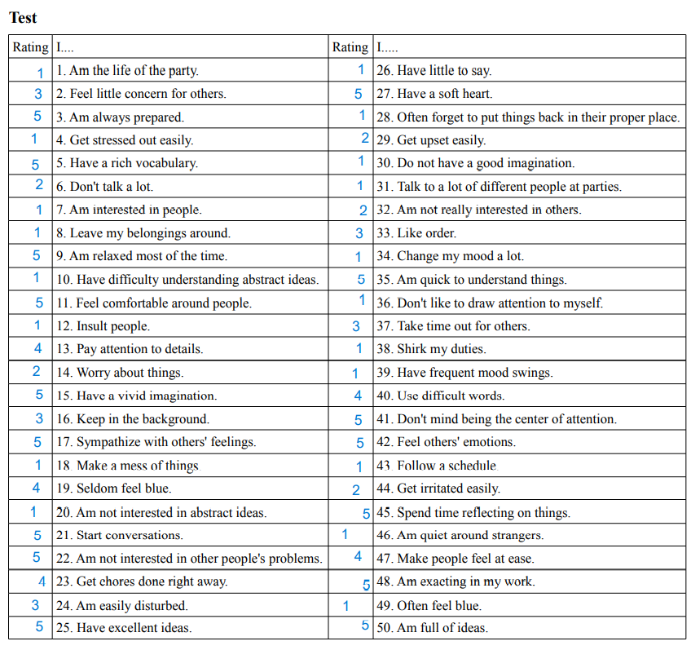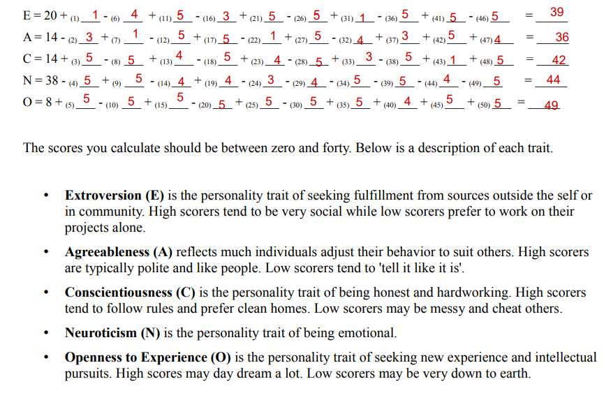

**INDIVIDUAL DISCUSSION**

The Big Five Personality Test has been quite informative as now I would be able to define my individual preferences. Of all the five traits, openness describes me the most. By nature, I am more adaptive towards learning new stuffs. My curiosity has driven me to join this course as I see myself as a good manager in the near future. Here, we meet different people, interact through discussion forums and gain new experiences. This is helping me to become a better person and also a good manager.  
When I was a child, I could totally relate myself to the trait of neuroticism. During my school days, I was known as the most tensed and anxious kid of the class! I was always worried for my grades. Worried to such an extent, that at times I used to skip my lunch so that I can learn my lessons. The fear of failure got on my nerves and it is used to affect my family members too. I used to live in anxiety all the time and once it has harmed my health a lot. With the help of regular discussions and counselling of my parents, I calmed myself and shifted my trait to openness.

* **TABLE 2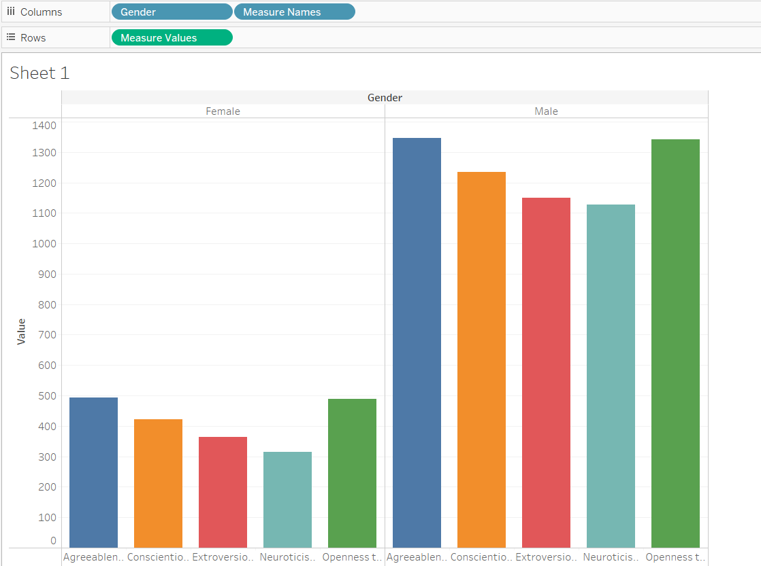:**

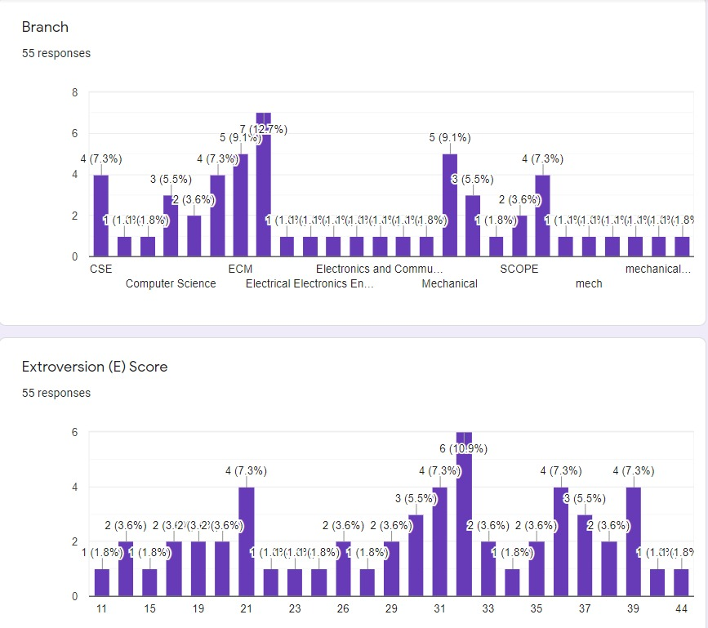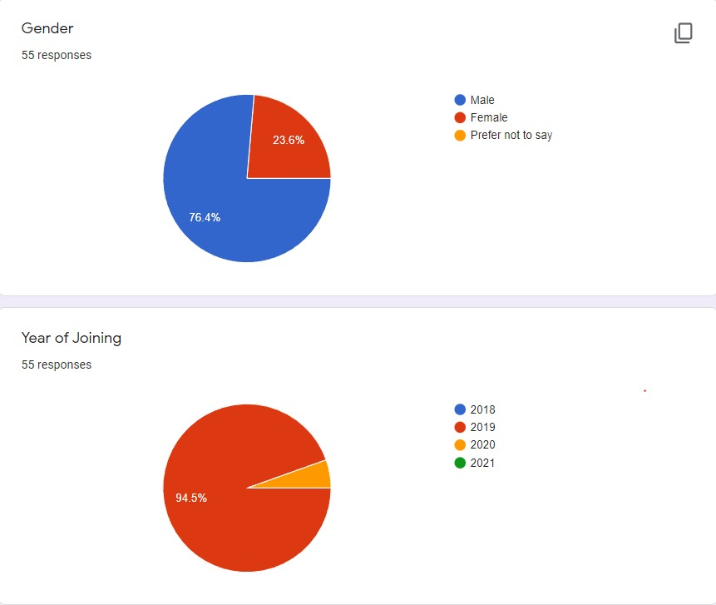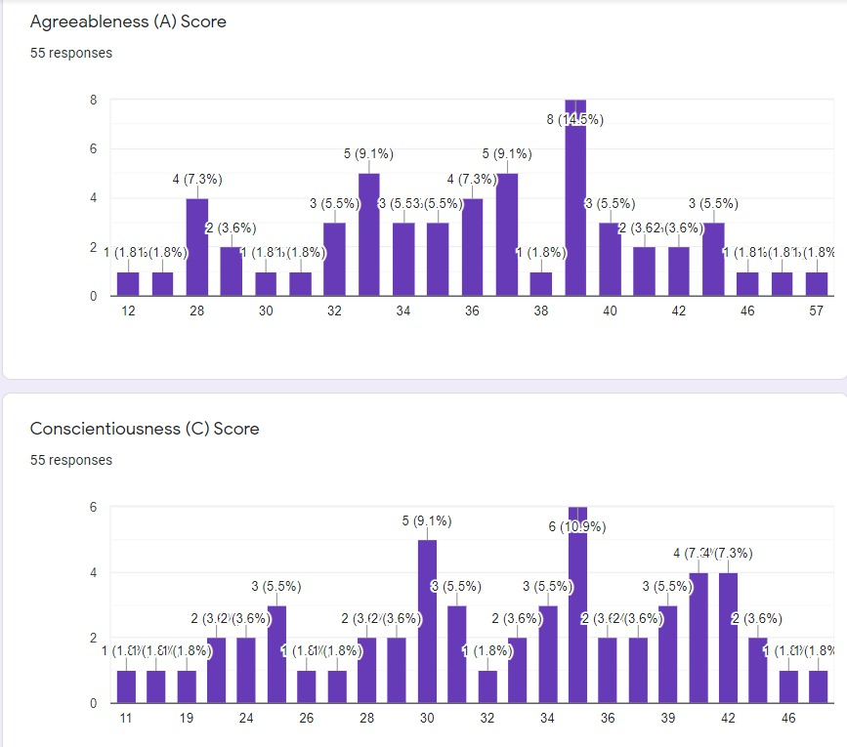

**GROUP DISCUSSION**

A candidate with a high openness score would be willing to learn new skills and tools. Presented with more abstract problems, they are more likely to think of abstract solutions and would be focused on tackling new problems that were perhaps previously overlooked.

Candidates with a high conscientiousness score wouldn’t necessarily be sat at their desk until midnight every evening! They would however be keen to get their work done, meet deadlines and be a self-starter; requiring little hand-holding to get the task done. Someone scoring low on the other hand, would need a lot more focus, time and attention to the task at hand.

The ideal extraversion scores would depend on the role you’re hiring for. Seen by many to be leaders in a team, a high extraversion score would do well in environments where they thrive off interaction with others:; sales, marketing & PR all require a level of people- facing skills. More technical job setups where specific focus or a degree of isolation is needed would, however, not be a good fit.

A candidate who shows high agreeableness would suit a role where personal skills and an ability to be at the service of others are needed. Of course, the opposite would be bad in a strong team environment and cause significant issues in order to work towards a common goal or task.

Finally, a candidate who exhibits high neuroticism will not be suited to a role where there are consistent changes, tasks that require strong self-starter tendencies or high stress levels. Those with low neuroticism scores will, however, thrive in these kinds of workplace scenarios.

* **CONCLUSION**

­­­­­­­ The human resources is the most important resources and asset that organization can boast of in the 21st century workplace since organization are run and steered by people. It is through people that goals are set and objectives attained. Thus, the performance of an organization is dependent on the sum total of the performance of its members. In today’s global and competitive environment, the general consensus is that organizations that capitalize on diversity are likely to perform better than organizations without the advantages that diversity brings. This diverse workforce must work in form of teams and group and creating a sense of commitment is the key element for organizational citizenship. Once organization’s employees exhibit positive personality traits, it also improves the group performance. Based on the findings of this study, it can be concluded that personality traits such as extroversion, openness to experience ,conscientiousness and agreeableness have significant impact on group performance.